**Pricing and Conditions:**

**Contents**

**Pricing and Conditions**  
**Introduction to the Condition Technique**  
**Condition Types**   
**Condition Tables**   
**Access Sequences**  
**Pricing Procedures**  
**How Condition Technique Elements Work Together**  
**Pricing in Sales Documents**  
**Pricing Elements in Sales Order Processing**   
**Prices**   
**Surcharges and discounts**   
**Freight Charges**   
**Sales Taxes**   
**Prerequisites for Automatic Pricing**  
**Pricing Screens in Sales Documents**  
**Header and Item Conditions**   
**Manual Pricing**  
**Distribution Between Header and Items**   
**Implementing a New Pricing Procedure**  
**Pricing Analysis**  
**Condition Records**   
**Condition Maintenance**   
**Maintaining Condition Records**  
**Customer-Specific Enhancements**   
**Maintaining with Selection Using the Condition Type**  
**Dynamic Field Check**   
**Release Procedures**  
**Validity Periods**   
**Table Displays**  
**Long Texts in Conditions**  
**Pricing Scales**  
**Pricing with Graduated Scales**  
**Condition Supplements**   
**Condition Exclusion**  
**Upper and Lower Limits**   
**Reference Conditions**  
**Changing Condition Records**   
**Change Documents for Condition Records**   
**Copying Condition Records**   
**Copying Condition Records**   
**Selecting From Alternative Copying Rules**   
**Deleting a Condition Record**   
**Condition Index**   
**Special Condition Record Functions**  
**Terms of Payment**

**Tracking Cumulative Values With Condition Update**  
**Maximum Values**   
**Maximum Quantities**   
**Maximum Number of Sales Orders**   
**Special Pricing Functions**   
**Promotional Pricing Agreements**   
**Creating Promotions and Sales Deals**  
**Creating Condition Records Within a Sales Deal**   
**Release Status**  
**Budget Assignment**  
**Budget Assignment in SD**  
**Using Variable Views of Condition Record Data**   
**Selecting Variable Views of Condition Records**   
**Customer Expected Price**   
**Entering Customer Expected Price in the Sales Order**   
**Processing Lists of Orders With Price Discrepancies**   
**Cost**   
**Gross Prices**  
**Condition Exclusion**  
**Variant Conditions**  
**Minimum Order Value**   
**Sales Order Costing in Pricing**  
**Duplicating Conditions**   
**Cumulating Conditions**   
**Group Conditions**   
**Pallet Discounts**   
**Hierarchical Accesses**  
**Data Determination in the Access**  
**Data Determination using a Communication Structure**   
**Data Determination using Routines**   
**Data Determination for Sales Deals**   
**Price Book**  
**Condition Interchange**   
**Outbound Processing**   
**Inbound Processing**  
**Distribution Scenarios**   
**Customizing**   
**Customer Exits**  
**Serialization**  
**Pricing Information and Analysis**   
**Pricing Analysis**

**Pricing Reports**  
**Creating Pricing Reports**  
**Running a Pricing Report**  
**Net Price Lists**

SD – Pricing

Pricing in Sales and Distribution is used to define the **calculation of prices for external vendors or customers and cost**. This condition is defined as a set of conditions when a price is calculated.

Example

Consider a case when customer orders specific quantity of a product on a particular day. Various factors **like customer, product, order quantity and date tells the final price to that customer.** This information is stored in the system as master data in the form of condition records.

There are various pricing elements **like prices, surcharges, discounts, and taxes,** which are defined in SAP system as condition types. To manage pricing information for a pricing element in a system, you have to create condition records.

Manual Pricing

While processing a sales order, you can also manipulate **the pricing at the item as well as the header level**. Manual processing of a price screen is dependent on individual condition types. During a Sales Order processing using manual processing for a condition type, you can perform the below activities −

* Deleting the pricing element.
* Changing a condition amount.
* Entering additional pricing elements.

How to add Pricing elements manually?

If you want to add customer discount manually in the pricing screen of a sales order, click on Add line. In Data screen, you can enter additional conditions like – customer discount in the condition type field. Enter a percentage range and then press ENTER. You can also delete pricing elements in item pricing and header screens. To do this, select the particular condition by positioning the cursor and click on delete line.

Note that all header conditions defined at header level cannot be changed at the item level, and conditions defined at this level cannot be changed at the header level. Only the Conditions that you define at both header and item conditions can only be edited at both levels.

**SD - Condition Record & Table**

A Condition table is defined as a combination of keys to identify an individual condition record. A condition record is defined as how system stores the specific condition.

**Example of a Condition Record** − Entering the price of a product or to specify the discount for a privileged customer.

**Example of a Condition Table** − Condition records for a customer specific material prices are stored by a sales department. SAP system contains a conditional table 005 for this purpose. Key of table 005 includes the following field −

* Customer
* Material
* Sales Organization
* Distribution Channel

In the first two fields, the customer and material determines the relationship between customers and specific materials. The last two fields are used to identify organization data in a SAP system. Now, if sales department in an organization enters a condition record for discount to one privileged customer, the system will automatically make use of the condition table 005 to store the record and define a key. Any standard SAP system contains predefined condition tables and specifies for each access in a predefined access sequence.

Creating Condition Tables

In a SAP system, you can create or change existing condition tables. As per the new business requirement in an organization, you can create new condition tables.

Go to SPRO → IMG → Sales and Distribution → Basic Functions → Pricing → Pricing Control → Define Conditional Tables

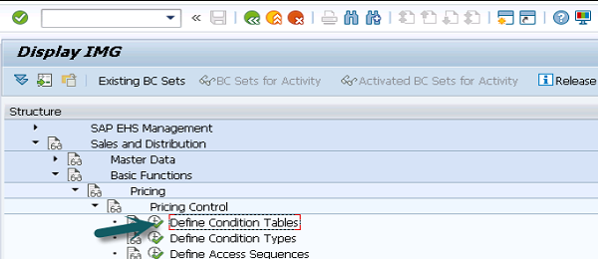

A new window will open and then you can select from create, change or display field as per the requirement. To create a new table, you have to select create and click on Choose.

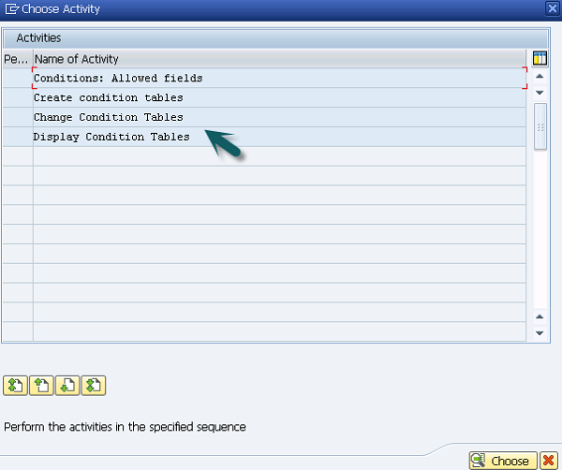

Enter condition table in table field and then you can enter the existing table to copy the condition.

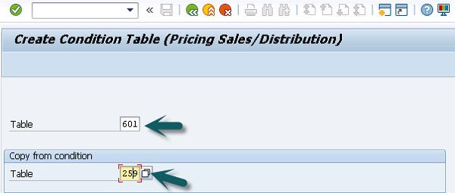

Once data is copied, you can modify the table as per the business requirement.

SD - Condition Techniques & Types

Condition type is defined as specific features of daily pricing activities in a SAP system. Using the condition type, you can also put different condition types for each pricing, discounts on goods, tax and surcharge that occurs in business transactions.

Example

Condition type allows you to define the discount for special material. This can be specified in the system to calculate discount as an amount or it can calculate discount in terms of percentage. In case you have to use both discount types, two separate condition types have to be defined in the system.

There are predefined condition types in a standard system −

|  |  |
| --- | --- |
| **S.No** | **Condition Type & Description** |
| 1 | **PR00**  Price |
| 2 | **K004**  Material Discount |
| 3 | **K005**  Customer-specific material discount |
| 4 | **K007**  Customer discount |
| 5 | **K020**  Price group discount |
| 6 | **KF00**  Freight surcharge(by item) |
| 7 | **UTX1**  State tax |
| 8 | **UTX2**  Country tax |
| 9 | **UTX3**  City tax |

How to create or change an existing condition type in a system?

You can change or maintain existing condition type in a standard system. You can also create a new condition types as per business requirements in your organization.

Go to SPRO → IMG → Sales and Distribution → Basic Functions → Pricing → Pricing Control → Define Condition Types

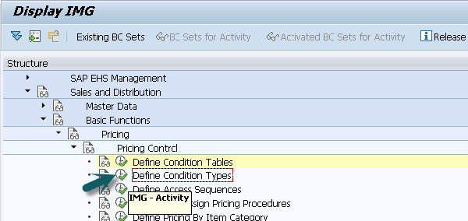

A new window will open. Select maintain and then change as per the requirement and click on Choose.

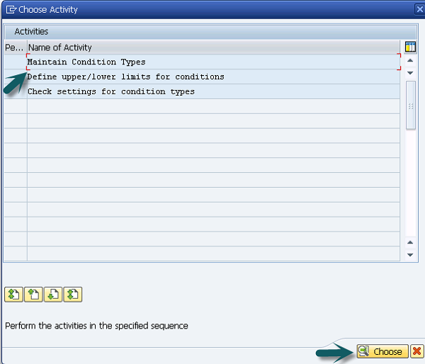

Once you select Maintain Condition Types and click on Choose, a new window will open. Select a condition type and click on copy.

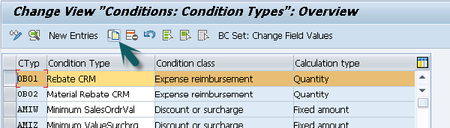

Enter the name of condition type. Fill the details for Control Data −

* Condition Class (A, B, D, E)
* Condition Type (A-Percentage, B- Amount, C, G)
* Condition Category (Cost, Price, etc.)
* Rounding rule (Commercial, round up, round down)
* Structure Condition
* Plus/Minus

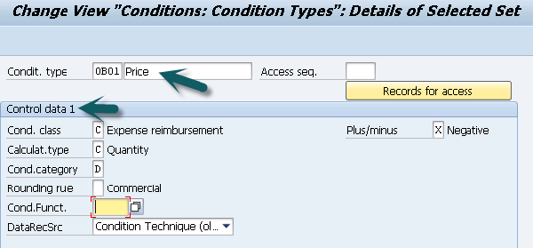

Group Condition data

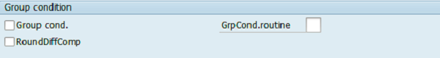

Changes which can be made

Changes Made

Master Data Section

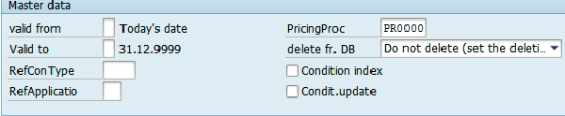

Scale and Control Data 2 section

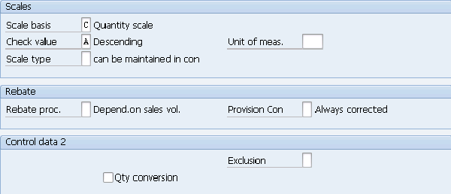

Once all the details are entered, click on the save icon at the top.

SD - Access Sequence

This is the search strategy, which is used by the system to find valid data for a particular condition type. It tells about the order in which a system searches for the data. An access sequence consists of one or more access sequences. It helps the system to search first, second and so on until it finds a valid record. An access sequence is defined for each condition type where a condition record is created.

You can create or maintain access sequence in customizing −

Go to SPRO → IMG → Sales and Distribution → Basic Functions → Pricing → Pricing Control → Define Access Sequences.

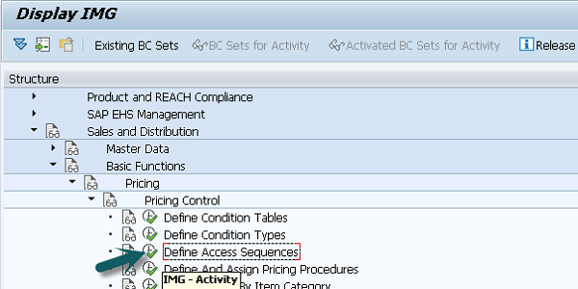

Determine Pricing by item Category

It is not necessary that all the items are suitable for pricing or not. If an item is not relevant for pricing, then line item will be blank for that item. An Item category is used to control the pricing of an item.

Billing Item Categories

* An item is suitable for billing?
* Cost of item should be determined?
* Is it a return item?
* Whether it is a statistical item?

**T-Code: OVKO**

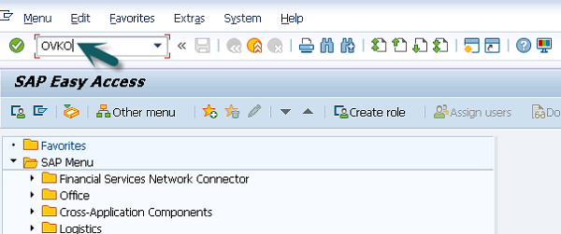

Enter Pricing flag in pricing field.

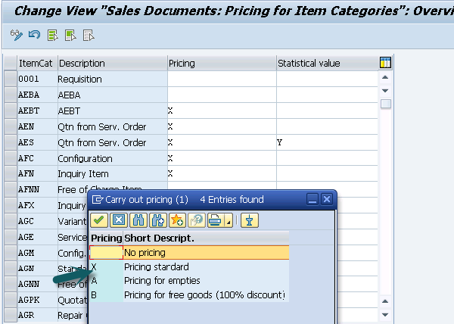

Enter Statistical value as − Blank, X, Y. Statistical value flag control an item in sales document as shown below.

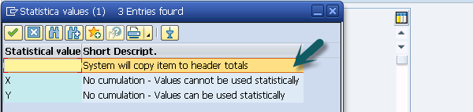

Click the save button.

Save_button

Data Saved

SD - Prices, Surcharges & Discounts

Prices and Types

In a standard SAP system, price is defined as gross price of a material. Below are the predefined price types in a system −

* Material Price
* Price List Type
* Customer specific price

By default, the system takes gross price in the automatic pricing for a business transaction. In a standard SAP system, system takes customer specific price. If no such price exists, system checks for a valid price list type. If this is also not present in the system, it takes the material price.

Material Prices

When material price is created, it means – the price for a specific material or pricing for a specific material type. A combination of sales organization and distribution channel for which material price is valid.

Price List Types

As per your business requirement in an organization, you can define your own price list.

**Example** − Price list can be created as per the customer type like Retail, Wholesale customer and so on. Price list can also be created as per currency type.

**Customer Specific Prices** − You can also create pricing records for specific customers. You can assign pricing record for specific combination of customers and material type.

Surcharges and Discounts

A standard SAP system includes a variety of common discount types. You can also define or customize discounts and surcharges as per the business requirement.

A Standard SAP system includes the below mentioned discount types −

|  |  |
| --- | --- |
| Discount(Key) | Kind of Discount |
| Customer(K007) | Percentage |
| Material(K004) | Absolute |
| Price group(K020) | Percentage |
| Material group(K029) | Absolute discount by weight |
| Customer/material(K005) | Absolute |
| Customer/material group(K030) | Percentage |
| Price group/material(K032) | Absolute |
| Price group/material group(K030) | Percentage |
| Rebate processing(BO01) | Group rebate(%) |
| Rebate processing(BO02) | Material rebate(fixed) |
| Rebate processing(BO03) | Customer rebate(%) |
| Inter-company processing(PI01) | Intercompany discount(fixed) |
| Inter-company processing(PI02) | Intercompany discount(%) |
| Invoice lists(RL00) | Factoring discount |
| Invoice lists(MW15) | Factoring discount tax |

While creating a condition record, you can use any of above standard discount types. While doing automatic pricing, system checks for the discount that satisfies a certain condition and it checks for a valid condition record. If a discount refers to a group like a material group or price groups, that particular group must be assigned to a relevant customer or material master record before automatic pricing is done in the system.

SD - Product Proposals

A Product Proposal helps an organization to increase the sales by recommending other products to the already added products or by replacing the one already added. The products recommended can be cheaper, expensive or similar to the product that are requested by the customer.

An Automatic Product Proposal is one of the most powerful tool used in online marketing of products. Product Proposals can be mapped to specific requirement of business partners to match their market requirement. You can use Top n Product list to provide the list of products proposed. The data in a product proposal is integrated with SAP CRM module to get product master data.

A Product proposal also supports features like cross selling, up selling and down selling, Top N Product list, proposing accessories for specific products and generating product proposals with respect to specific promotions.

* **Cross Selling** − The product association rules are defined for products and relationship between different products. Each rule contains a leading product and the dependent products to be suggested with these products. This allows you to offer other products with the one already added by a customer.
* **Up-Selling and Down Selling** − If you are selling a specific product you can define other products to be proposed. These proposed products are defined using down selling and up selling rules.
* **Top N Product Lists** − With the use of SAP NetWeaver BI component, you can define a list of top products for a target group.
* **Proposing Accessories** − This is maintained in the product master data and with already added products. It suggests suitable accessories that can be added.
* **Generating Product Proposal w.r.t specific promotions** − You can assign a specific product to a promotion for a customer.

SD - Listing, Determination & Exclusion

Listing, Determination and material exclusion is a key feature provided by SAP SD that allows the sale of materials to allowed/disallowed customers.

* **Listing** − You can create a material list for specific customers, which allows those customers to order only those materials which are maintained in the list.
* **Exclusion** − You can also maintain an exclusion record for specific customers and this doesn’t allow that customer to order those materials.

To display Material listing and exclusion, go to SPRO → Sales and Distribution → Basic functions → Listing/Exclusion.

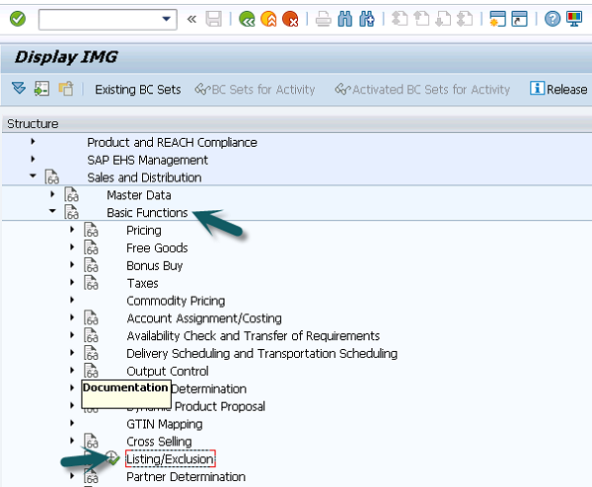

A new window will open, then you can Activate Listing/Exclusion as shown in the following image and then click choose.

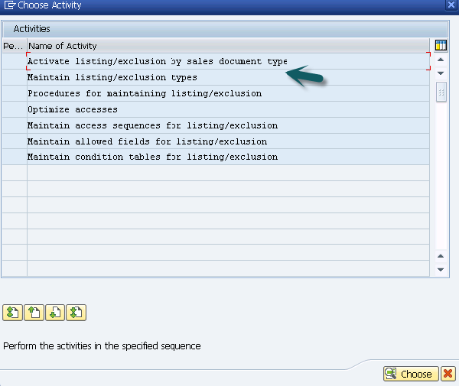

It will show you the existing material listing and exclusion as per the selection.

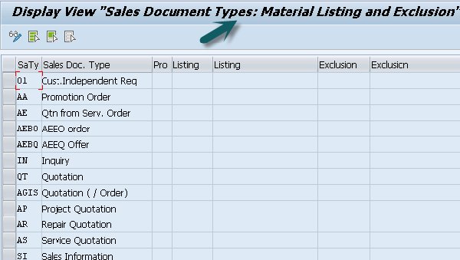

Creating Material Exclusion

**Use T-Code: VB01**

Select **Exclusion Type: B001** and click Key combination to select material and customer.

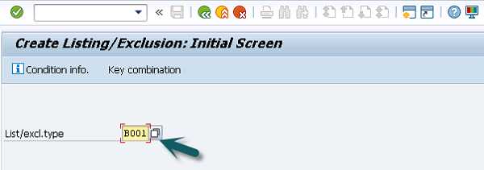

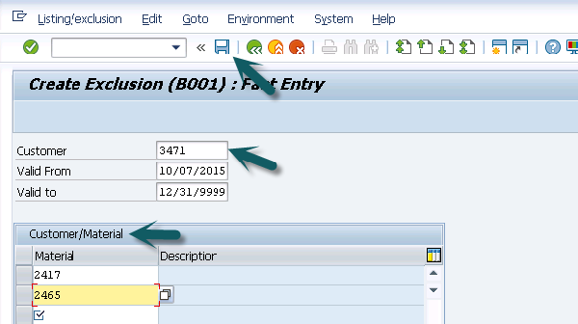

Click on the save icon and a confirmation message will be displayed.

Condition Records